**Output 1:**

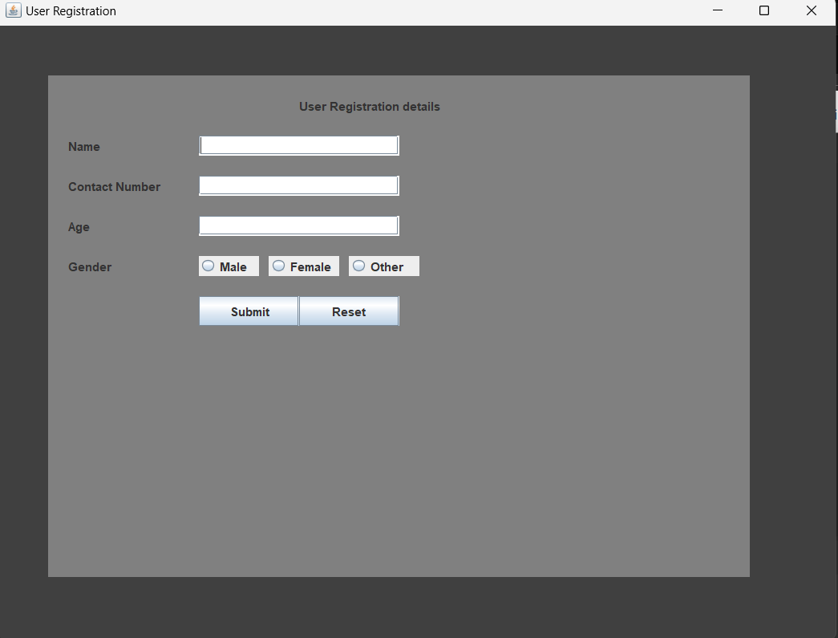

**Output 2:**

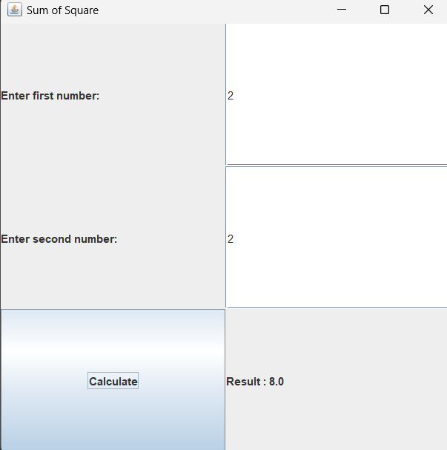

**Output 3:**

**Output 4:**

**Output 5:**

**Output 6:**

**Lab 2**

**Output 1:**

**Output 2:**

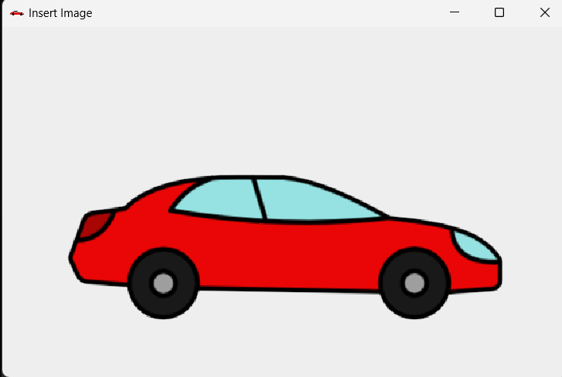

**Output 3:**

**Output 4:**

**Output 5:**

**Lab 3**

**Output 1:**

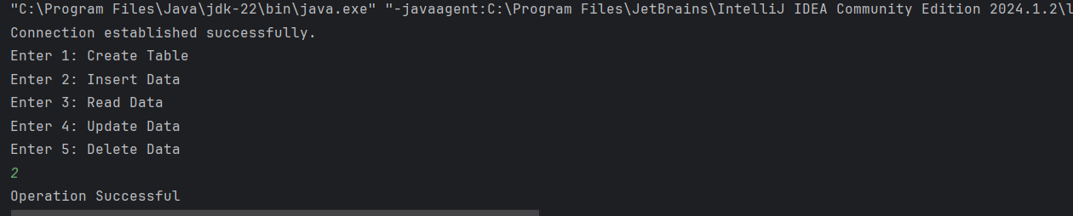

**Output 2:**

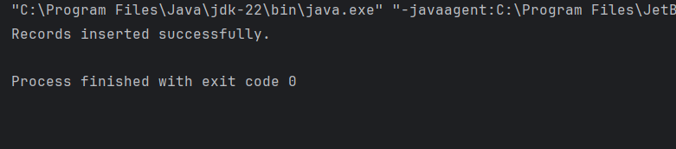



**Tribhuvan University**

**Faculty of Humanities and Social Science**

**Bachelors in Computer Application**

**Everest Innovative College**

**Solteemode, Kathmandu**

**LAB REPORT**

**OF**

**ADVANCED JAVA**

**Submitted By:**

Nhujit Bajracharya

BCA-6th Semester

Batch-2020

**Submitted To:**

Shyam Maharjan

Lecturer

Everest Innovative College

\

**………......………………..**

**Signature**



**Tribhuvan University**

**Faculty of Humanities and Social Science**

**Bachelors in Computer Application**

**Everest Innovative College**

**Solteemode, Kathmandu**

**LAB REPORT OF**

**ADVANCED JAVA**

**LAB-1**

**Submitted By:**

Nhujit Bajracharya

BCA-6th Semester

Batch-2020

**Submitted To:**

Shyam Maharjan

Lecturer

Everest Innovative College

\

**………......………………..**

**Signature**



**Tribhuvan University**

**Faculty of Humanities and Social Science**

**Bachelors in Computer Application**

**Everest Innovative College**

**Solteemode, Kathmandu**

**LAB REPORT OF**

**ADVANCED JAVA**

**LAB-2**

**Submitted By:**

Nhujit Bajracharya

BCA-6th Semester

Batch-2020

**Submitted To:**

Shyam Maharjan

Lecturer

Everest Innovative College

\

**………......………………..**

**Signature**



**Tribhuvan University**

**Faculty of Humanities and Social Science**

**Bachelors in Computer Application**

**Everest Innovative College**

**Solteemode, Kathmandu**

**LAB REPORT OF**

**ADVANCED JAVA**

**LAB-3**

**Submitted By:**

Nhujit Bajracharya

BCA-6th Semester

Batch-2020

**Submitted To:**

Shyam Maharjan

Lecturer

Everest Innovative College

\

**………......………………..**

**Signature**